TC-CSC-030
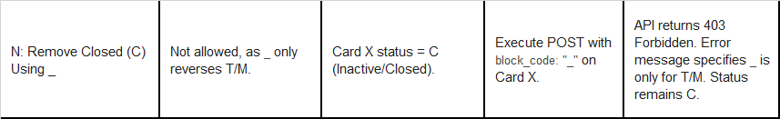
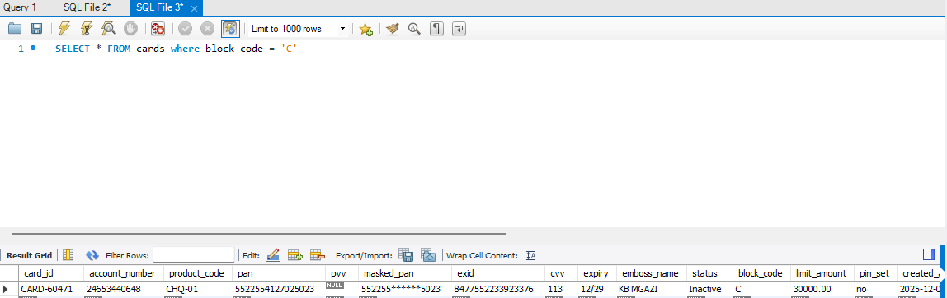
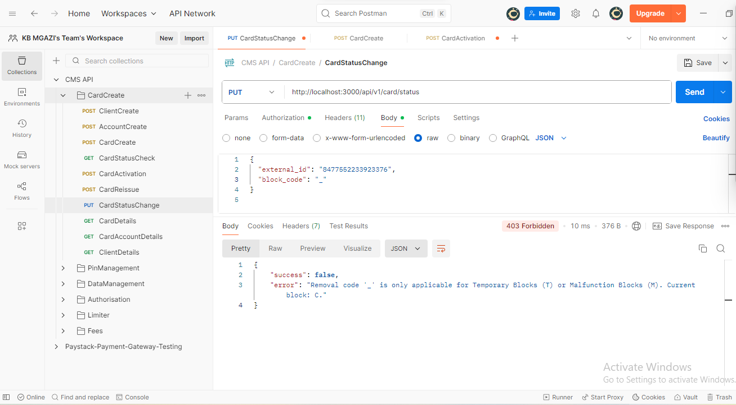
Request:
{
"external_id": "8477552233923376",
"block_code": "_"
}

Response:
{
"success": false,
"error": "Removal code '_' is only applicable for Temporary Blocks (T) or Malfunction Blocks (M). Current block: C."
}

